UNITED STATES

SECURITIES AND EXCHANGE COMMISSION
Washington, D.C. 20549

SCHEDULE 13G

Under the Securities Exchange Act of 1934

(Amendment No. 2)*

Cango Inc.

(Name of Issuer)

Class A Ordinary Shares, par value US$0.0001 per share

(Title of Class of Securities)

137586 103 (1)

(CUSIP Number)

December 31, 2021

(Date of Event which Requires Filing of this Statement)

Check the appropriate box to designate the rule pursuant to which this Schedule is filed:

- Rule 13d-1(b)

- Rule 13d-1(c)

☒ Rule 13d-1(d)

*The remainder of this cover page shall be filled out for a reporting person’s initial filing on this form with respect to the subject class of securities, and for any subsequent amendment containing information which would alter the disclosures provided in a prior cover page.

The information required in the remainder of this cover page shall not be deemed to be “filed” for the purpose of Section 18 of the Securities Exchange Act of 1934 (“Act”) or otherwise subject to the liabilities of that section of the Act but shall be subject to all other provisions of the Act (however, see the Notes).

- This CUSIP number applies to the Issuer’s American Depositary Shares, each representing two Class A ordinary shares.

SCHEDULE 13G

CUSIP No. 137586 103

1 Names of Reporting Persons


Xiaojun Zhang
2 Check the Appropriate Box if a Member of a Group (See Instructions)
(a) ☐ |  |  | (b) ☐
3 SEC Use Only
4 Citizenship or Place of Organization
People’s Republic of China
 |  | 5 | Sole Voting Power
Number of |  |  | 40,778,835(1)
Shares |  | 6 | Shared Voting Power
Beneficially |  |  | 0
Owned by |  |  | 0
Each |  | 7 | Sole Dispositive Power
Reporting
Person |  |  | 40,778,835(1)
With:
With: |  | 8 | Shared Dispositive Power

0

9 Aggregate Amount Beneficially Owned by Each Reporting Person

40,778,835(1)

10 Check if the Aggregate Amount in Row (9) Excludes Certain Shares (See Instructions)

☐

11 Percent of Class Represented by Amount in Row (9)

15.1% of Class A ordinary shares assuming conversion of the Class B ordinary shares held by the reporting person only into Class A ordinary shares.(2) The voting power of the shares beneficially owned by the reporting person represent 45.4% of the total outstanding voting power.(3)

12 Type of Reporting Person (See Instructions)

IN

- Represents (i) 38,275,787 Class B ordinary shares held by Eagle Central Holding Limited and (ii) 2,503,048 Class A ordinary shares that

Mr. Xiaojun Zhang has the right to acquire within 60 days after December 31, 2021 pursuant to the terms of the options granted to him under the Issuer’s share incentive plan.
- The percentage of the class of securities beneficially owned by each reporting person is calculated based on (i) 229,831,213 Class A ordinary shares of the Issuer issued and outstanding as of December 31, 2021 and (ii) 38,275,787 Class B ordinary shares beneficially owned by the reporting person as of December 31, 2021, assuming the conversion of all such Class B ordinary shares into the same number of Class A ordinary shares.

- The percentage of voting power is calculated by dividing the voting power beneficially owned by such person or group by the voting power of a total of 229,831,213 Class A ordinary shares and 72,978,677 Class B ordinary shares of the Issuer issued and outstanding as of December 31, 2021. In respect of all matters subject to a shareholders’ vote, each Class A ordinary share is entitled to one vote, and each Class B ordinary share is entitled to 20 votes, voting together as one class. Each Class B ordinary share is convertible into one Class A ordinary share at any time by the holder thereof. Class A ordinary shares are not convertible into Class B ordinary shares under any circumstances.

In May 2018, the Issuer’s co-founders Mr. Xiaojun Zhang and Mr. Jiayuan Lin entered into a voting agreement, which was amended and restated in June 2019. Pursuant to the amended and restated voting agreement, the co-founders shall reach a consensus before exercising their voting rights with respect to the Issuer’s shares. As of December 31, 2021, the co-founders collectively exercised 86.7% of the aggregate voting power of the Issuer’s issued and outstanding share capital.

Page 2 of 8

1 Names of Reporting Persons
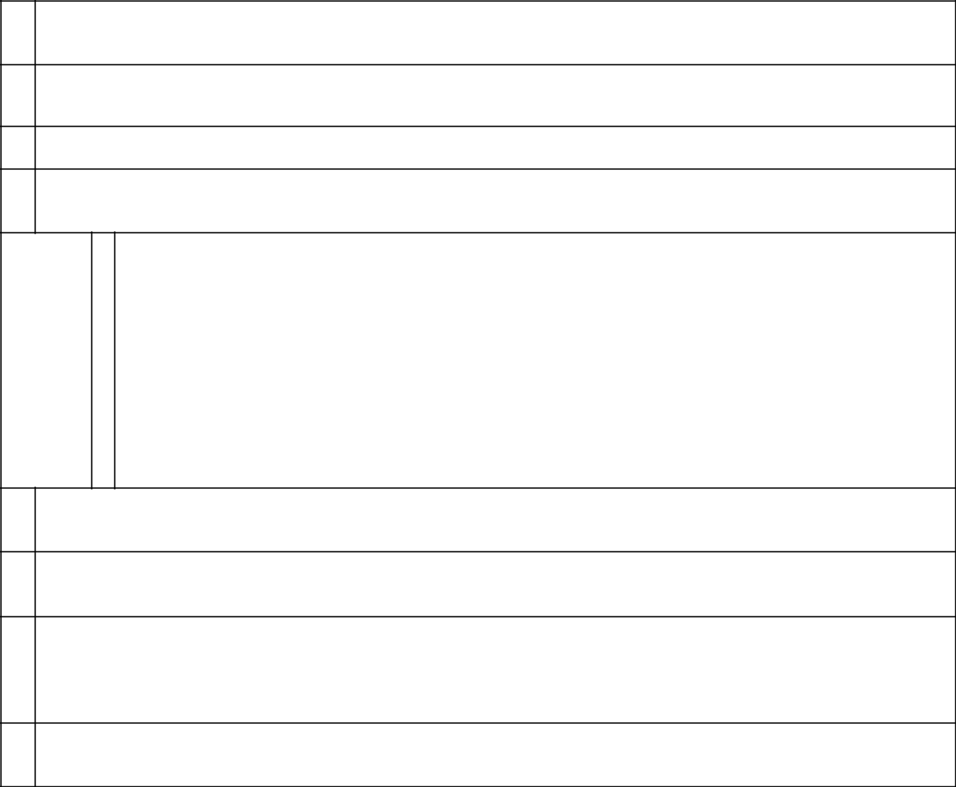

Eagle Central Holding Limited

2 Check the Appropriate Box if a Member of a Group (See Instructions)

(a) ☐ (b) ☐

3 SEC Use Only

4 Citizenship or Place of Organization

British Virgin Islands

 |  | 5 | Sole Voting Power
Number of |  |  | 38,275,787(1)
Number of |  | 6 | Shared Voting Power
Shares
Beneficially |  |  | 0
Owned by |  |  | 0
Each |  | 7 | Sole Dispositive Power
Reporting
Person |  |  | 38,275,787(1)
With:
With: |  | 8 | Shared Dispositive Power

0

9 Aggregate Amount Beneficially Owned by Each Reporting Person

38,275,787(1)

10 Check if the Aggregate Amount in Row (9) Excludes Certain Shares (See Instructions)

☐

11 Percent of Class Represented by Amount in Row (9)

14.3% of Class A ordinary shares assuming conversion of the Class B ordinary shares held by the reporting person only into Class A ordinary shares.(2) The voting power of the shares beneficially owned by the reporting person represent 45.3% of the total outstanding voting power.(3)

12 Type of Reporting Person (See Instructions)

CO

- Represents 38,275,787 Class B ordinary shares held by Eagle Central Holding Limited.

- The percentage of the class of securities beneficially owned by each reporting person is calculated based on (i) 229,831,213 Class A ordinary shares of the Issuer issued and outstanding as of December 31, 2021 and (ii) 38,275,787 Class B ordinary shares beneficially owned by the reporting person as of December 31, 2021, assuming the conversion of all such Class B ordinary shares into the same number of Class A ordinary shares.

- The percentage of voting power is calculated by dividing the voting power beneficially owned by such person or group by the voting power of a total of 229,831,213 Class A ordinary shares and 72,978,677 Class B ordinary shares of the Issuer issued and outstanding as of December 31, 2021. In respect of all matters subject to a shareholders’ vote, each Class A ordinary share is entitled to one vote, and each Class B ordinary share is entitled to 20 votes, voting together as one class. Each Class B ordinary share is convertible into one Class A ordinary share at any time by the holder thereof. Class A ordinary shares are not convertible into Class B ordinary shares under any circumstances.

Page 3 of 8

Item 1.

- Name of Issuer: Cango Inc.

- Address of Issuer’s Principal Executive Offices:

8F, New Bund Oriental Plaza II 556 West Haiyang Road Pudong, Shanghai

People’s Republic of China

Item 2.

- Name of Person Filing:

  - Xiaojun Zhang, a citizen of the People’s Republic of China; and

  - Eagle Central Holding Limited (“Eagle Central”), a company organized under the law of the British Virgin Islands and is wholly owned by Xiaojun Zhang.

- Address of Principal Business Office or, if None, Residence:

  - The address of Xiaojun Zhang is 8F, New Bund Oriental Plaza II, 556 West Haiyang Road, Pudong, Shanghai, People’s Republic of China.

  - The registered address of Eagle Central is the offices of Sertus Incorporations (BVI) Limited, Sertus Chambers, P.O. Box 905, Quastisky Building, Road Town, Tortola VG1110, British Virgin Islands.

- Citizenship:

Xiaojun Zhang is a citizen of the People’s Republic of China. Eagle Central is organized under the law of the British Virgin Islands.

- Title and Class of Securities:

Class A ordinary shares, par value US$0.0001 per share. Each Class B ordinary share is convertible into one Class A ordinary share at any time by the holder thereof. Class A ordinary shares are not convertible into Class B ordinary shares under any circumstances.

- CUSIP No.: 137586 103

Item 3. If this statement is filed pursuant to §§ 240.13d-1(b), or 240.13d-2(b) or (c), check whether the person filing is a:

Not applicable.

Page 4 of 8

Item 4. |  | Ownership
 |  |  |  |  |  |  |  |  | Shared |  | Sole power |  |  |  | Percentage
 |  |  |  |  |  |  | Sole power |  |  |  | to |  | Shared power
 |  |  | Amount |  |  |  |  |  | power to |  | dispose or to |  |  |  | of
Reporting |  |  |  |  | Percent |  | to vote or |  | vote or to |  | direct the |  | to dispose or |  | aggregate
 |  |  | beneficially |  |  |  | direct to |  | direct |  | disposition |  | to direct the |  | voting
Person(1) |  |  | owned(1) |  | of class(2) |  | vote(1) |  | the vote |  | of(1) |  | disposition of |  | power(3)
Xiaojun Zhang
 |  |  | 40,778,835 |  | 15.1% |  | 40,778,835 |  | 0 |  | 40,778,835 |  | 0 |  | 45.4%
Eagle Central |  | 38,275,787 |  |  | 14.3% |  | 38,275,787 |  | 0 |  | 38,275,787 |  | 0 |  | 45.3%
- As of December 31, 2021, Eagle Central directly owned 38,275,787 of the Issuer’s Class B ordinary shares. Eagle Central is wholly owned by Mr. Xiaojun Zhang. Accordingly, Mr. Xiaojun Zhang may thereby be deemed to beneficially own the 38,275,787 Class B ordinary shares owned by Eagle Central. In addition, Mr. Xiaojun Zhang has the right to acquire 2,503,048 Class A ordinary shares within 60 days after December 31, 2021 pursuant to the terms of the options granted to him under the Issuer’s share incentive plan.

- The percentage of the class of securities beneficially owned by each reporting person is calculated based on (i) 229,831,214 Class A ordinary shares of the Issuer issued and outstanding as of December 31, 2021 and (ii) 38,275,787 Class B ordinary shares beneficially owned by the reporting person as of December 31, 2021, assuming the conversion of all such Class B ordinary shares into the same number of Class A ordinary shares.

- The percentage of voting power is calculated by dividing the voting power beneficially owned by such person or group by the voting power of a total of 229,831,213 Class A ordinary shares and 72,978,677 Class B ordinary shares of the Issuer issued and outstanding as of December 31, 2021. In respect of all matters subject to a shareholders’ vote, each Class A ordinary share is entitled to one vote, and each Class B ordinary share is entitled to 20 votes, voting together as one class. Each Class B ordinary share is convertible into one Class A ordinary share at any time by the holder thereof. Class A ordinary shares are not convertible into Class B ordinary shares under any circumstances.

In May 2018, the Issuer’s co-founders Mr. Xiaojun Zhang and Mr. Jiayuan Lin entered into a voting agreement, which was amended and restated in June 2019. Pursuant to the amended and restated voting agreement, the co-founders shall reach a consensus before exercising their voting rights with respect to the Issuer’s shares. As of December 31, 2021, the co-founders collectively exercised 86.7% of the aggregate voting power of the Issuer’s issued and outstanding share capital.

Item 5. Ownership of Five Percent or Less of a Class.

Not applicable.

Item 6. Ownership of More Than Five Percent on Behalf of Another Person.

Not applicable.

Item 7. Identification and Classification of the Subsidiary Which Acquired the Security Being Reported on by the Parent Holding Company or Control Person.

Not applicable.

Item 8. Identification and Classification of Members of the Group.

Not applicable.

Page 5 of 8

Item 9. Notice of Dissolution of Group.

Not applicable.

Item 10. Certifications.

Not applicable.

Page 6 of 8

SIGNATURES

After reasonable inquiry and to the best of our knowledge and belief, the undersigned certify that the information set forth in this statement is true, complete and correct.

Dated: February 14, 2022

Xiaojun Zhang

By: | /s/ Xiaojun Zhang
Name: | Xiaojun Zhang
Title: | Chairman

Eagle Central Holding Limited

By: | /s/ Xiaojun Zhang
Name: | Xiaojun Zhang
Title: | Authorized Signatory

Page 7 of 8

EXHIBIT INDEX

Exhibit No. | Description
99.1 |  | Joint Filing Agreement

Page 8 of 8

Exhibit 99.1

Joint Filing Agreement

In accordance with Rule 13d-1(k) promulgated under the Securities Exchange Act of 1934, as amended, the undersigned hereby agree to the joint filing on behalf of each of them of a statement on Schedule 13G (including amendments thereto) with respect to Class A ordinary shares, par value US$0.0001 per share, of Cango Inc., a Cayman Islands company, and that this Agreement may be included as an Exhibit to such joint filing. This Agreement may be executed in any number of counterparts, all of which taken together shall constitute one and the same instrument.

[Signature Page Follows]

IN WITNESS WHEREOF, the undersigned hereby execute this Agreement as of February 14, 2022.

Xiaojun Zhang

By: /s/ Xiaojun Zhang

Name: Xiaojun Zhang

Title: Chairman

Eagle Central Holding Limited

By: /s/ Xiaojun Zhang

Name: Xiaojun Zhang

Title: Authorized Signatory

